Supporting Material

Rhys Davies,
Senior Lecturer in Creative Sound Design,
Department of Media Arts,
Royal Holloway,
University of London

Bed-sitter Sunday Blues
The History of the Demonstration:
Tape/Cassette/Compact Disk/Mp3

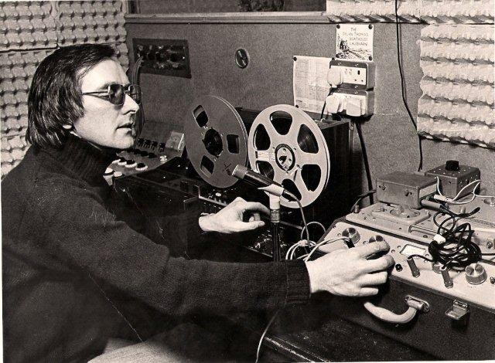

John Davies in his garage/studio conversion 1976
Picture courtesy of the South Wales Evening Post

The demo-tape has been a music industry staple since the late 1950s. Generations of bands and singer songwriters have sought out the means to record demonstrations of their material for a variety of reasons, the most popular of which is to be ‘discovered’ and to make it as a Rock Star.

It’s the hope that kills you
It is misleading to state that the (unsolicited) demo-tape has ever played a significant role in the decision-making processes of the record industry. Very rarely will a demo tape be the primary motivation for signing an artist to a recording contract. In fact, in times past, an A&R Department (Artists & Repertoire) would rarely listen to an unsolicited tape. This is not insider information – everyone knew this to be the case and yet the demo’ tape remained an integral part of the industry until very recently.

Who needs a deal?
The rapid development of affordable digital technology that began in the late 1980s has meant that artists now have the tools to produce their own albums to an industry quality standard, without the necessity to book expensive studio time. This has been the case for some years. However, having a studio quality album is not enough. You still have to effectively promote and distribute your ‘product’. Throughout the 1990s, the policy of vertical integration of major labels was eroded to the point where most signed artists would record independently of label studios and consequently, record labels evolved into predominantly marketing and distribution companies. With the rise of the ‘download’ market with iTunes in the vanguard, even this business model has become increasingly obsolete as formerly huge companies such as Virgin and EMI struggle to remain a relevant force in the contemporary market.

Example: Gomez ‘Bring It On’.
Winner of the Mercury prize 1998.
Recorded in their ‘Hut’
Distributed by Virgin.

The World Wide Web was the last piece of the puzzle that would allow artists to finally bypass music companies, whilst still being able to produce, market and distribute their music. The rise of social networking sites provoked a significant rise in the influence and the velocity of ‘word of mouth’, or ‘likes’. The Arctic Monkeys eventually signed to an independent label in 2005, after they had already achieved a significant level of commercial and critical success. One could argue that had this breakthrough been achieved today they probably wouldn’t have bothered signing a deal with any label. Many established artists, seeing potentially greater profits and full creative control have taken the Internet route. Radiohead released ‘In Rainbows’ in 2007, where subscribers were free to pay what they felt like.

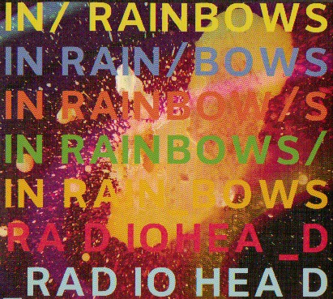

The demo-tape is still with us, but now it has been transformed into the ‘free downloadable tracks’ - tasters for those contemplating the purchase of the entire album on line. It is ironic that as a potential customer, one is able to listen to the first thirty seconds on any track available for purchase on iTunes, a faint echo of the obsolete three laws of demology.

The Three Laws of Demology
(When producing a demo-tape for industry consideration)

- Select a maximum of three songs.
Do not include more material. If your tape tempts an A&R department, it will be on the basis of your first three tracks. They will not listen to more. It is highly unlikely that they will listen to the first track all the way through.

- Track 1 of your demo-tape should be your strongest track.
It is not like an album, where the sequencing of tracks is important. Do not be tempted to save the best till last because no one will listen to it.

- No long Introductions
If you have been fortunate enough to get your demo-tape onto the A&R cassette player, they will give you between 20 – 30 seconds. If you haven’t engaged them by then, they will switch it off and throw it away. The best demo-tape song is one that gets into the action straight away, often by beginning with the chorus. *

* Artists will rarely write a track that opens with the chorus and often it is the producer who will define the structure and shape of a particular track. (Normally a pop song structure is: verse 1, chorus, verse 2, chorus, middle eight, solo, verse 3, chorus, end). Famous examples of this are The Beatles: She Loves You (1963); Strawberry Fields Forever (1967); Abba: Dancing Queen (1976).

The history of the demo-tape can be categorised into three distinct eras:

- Capturing the live Performance (1960 – 1970)

Before the advent of multi-track recording in the 1970s, artists and bands would look to capture the essence of a live performance with typically quite poor results. The reason for this was not the quality of the reel-reel/cassette recorder, but the environment in which the recording took place. Most bands would set up as if at a live gig and record the session using only one microphone positioned at distance. The captured audio was of a poor quality because there was no separation of sound and much of the signal picked up by the granular crystal microphone was reflected and not direct sound.

If, by way of analogy, one represents each instrument as an oil paint colour, then the art of production, both in the way the track is arranged and the way it is then recorded, is constructed to compliment each colour within the structure and arrangement of the music. If a painter were to simply combine those colours in an ad hoc fashion, the result would be a dull brown/green. This is also true with music. The combination of direct and reflected sound captured using just one recording source would usually result in the aural equivalent of a dull brown/green as reflections would multiply and aural fidelity lost.

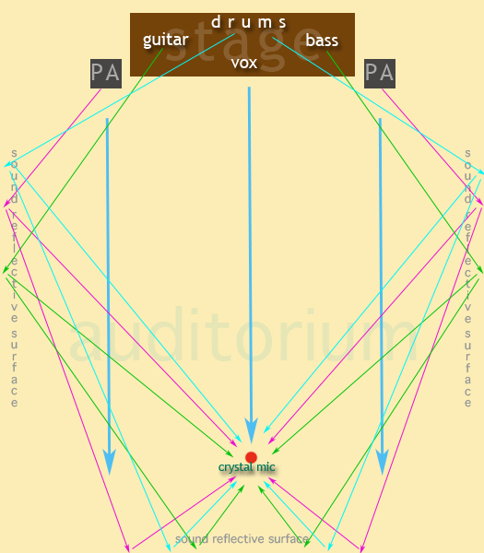

Direct & Reflected Sound
Produces aural saturation

Why do it then?

(i) In many cases, the motivation of the bands in this period was to produce a recording that would help them get better gigs. Bands correctly assumed the best way to get a record deal was to be discovered playing a gig.

(ii) Perhaps a demo would help the band acquire a manager, who could then get you better gigs and perhaps even solicit the demo-tape to radio stations and record companies on your behalf.

(iii) Often a band would record a demo just so they could hear what they sounded like. Music in its performed state exists in time only - an amorphous entity. However, once it has been captured, it becomes a tangible artefact. It becomes a solid proof of your existence as an artist. It is the beginning of the development of the creative aesthetic where a distinction is increasingly drawn between the notion of the recording being as something separate from the performed event – a process mirrored in the industry, where bands would experiment in the recording studio in a way unheard of before – again The Beatles were the first to experiment in this fashion with mid era tracks such as ‘Rain’ (1965) and the album ‘Revolver’ (1966), where they produced sonic works that were impossible to re-create in the live arena, a creative dissonance that ultimately contributed to their abandonment of touring in 1966 and their subsequent six month retreat into Abbey Road Studio 2 to record Sgt Pepper on a four channel multi-track. (1967). So central was the studio to their canon of work, they named their last album after their workspace, perhaps indicating that as a band they had reached a point in their personal and professional relationships where they only existed as a captured artefact.

Significantly then, recording studios in this period evolved into another creative tool for artists, where previously they merely provided the technology and acoustic spaces best suited to the re-creation of the live performance. Look at the difference between “Please, Please Me’ (1963), a cherry-picked collection of the Beatles’ Hamburg set-list, recorded in just one day, where original material and rock and roll covers jostled for position, and Revolver (1966), which was a genuine ‘album’ we would recognise today.

(iv) Unsigned bands soon learned to produce the best quality audio that the available technology of the period allowed. In this era, artists discovered the necessity of ‘deadening’ the recording space, by covering reflective surfaces with sound absorbent material. My father, when converting the family garage, separated the space into a control room and a recording booth and covered the walls with baffer-board and egg boxes (see cover picture). However, he failed to understand that the soft board and egg-boxes were only needed for the recording booth and that the control room should have been left untouched to recreate the playback environments of front rooms, kitchens and bed-sits. Deadening the mixing space resulted in some interesting mixes and the over use of ‘reverb’ to brighten the perceived ‘flat’ playback.

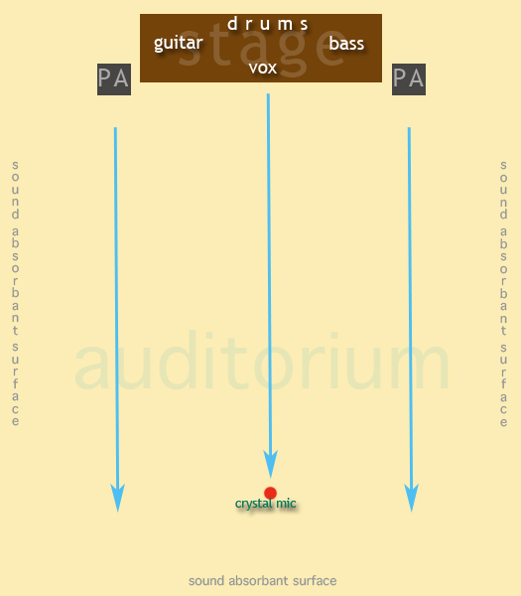
Direct Sound
Absorbent material covering the reflective surfaces
produces greater aural integrity

- Making a ‘Studio’ Recording (1970 – 1985)

As the development of domestically available sound technology emerged in the 1970s, artists and bands became far more sophisticated and ambitious. This perhaps marks the beginning of the end for the total dominance of mainstream record labels. The ability to create a stereo master from a multi-track recording was the main motivating factor in the establishment of the ‘indie’ scene, beginning with the iconic labels of the 1970s like Rough Trade and Stiff Records. The technology was still priced beyond most bands ability to purchase, but they could now hire a demonstration studio to record their three tracks. For the first time, artists recorded ‘studio’ albums to sell at their live gigs.

Technology:

- Sound on Sound (Layering) The Revox A77

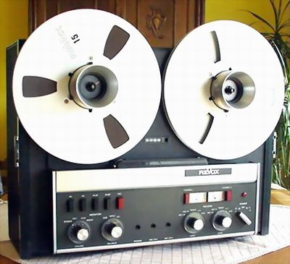
The original Mk1 model was available since the early 1960s and was designed as a stereo mastering and playback machine for commercial applications. It was a popular machine in theatres and radio studios because of the high quality of recording, ease of editing, the auto-stop and its physical robustness. Musicians bought them originally as a stereo recorder for live recording. They quickly found out it had a sound on sound capability. (Les Paul)

- Multi-track Recording (Quad Technology) Teac 3340

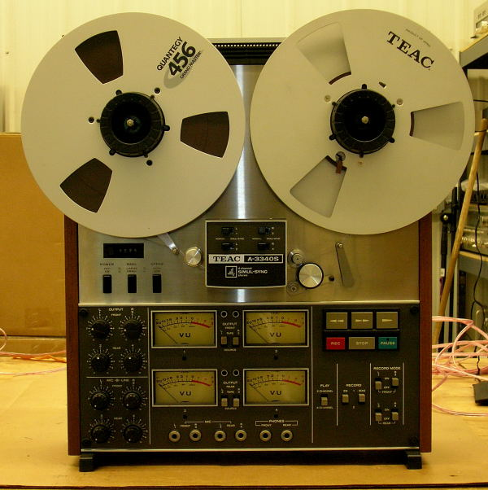
In 1973, Teac converted their Quadraphonic tape recorder for use as home multi-track recorders. There were still problems because of a lack of affordable mixing consoles. The Black Ark Studios run by Lee ‘Scratch’ Perry in Jamaica used this model to record Reggae albums throughout the 1970s – with an Alice mixing console that he referred to as a ‘toy’

- Early Mixing Console(s)

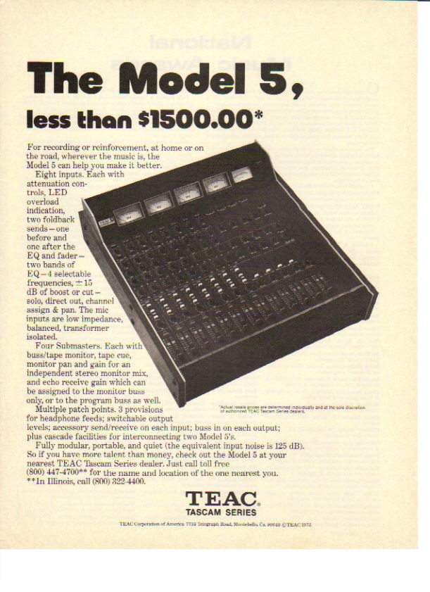
The development of high quality recorders did not prompt the home recording boom. Instead it was the introduction of input mixers that allowed the use of multiple microphone setups. This model, introduced in 1975, was designed for use with the 4 track Teac 3340/3440 recorders. By this time, home music producers now understood the impact of reflected sound when the microphone was placed a distance from the audio source. It was at this time that garages were converted to recording studios, where egg boxes covered the walls to absorb, rather than reflect the sound
- The rise of the home recording studios (1979 - )

In 1979, Tascam released the first ‘Portstudio’. This was a combined four track recorder (cassette) and mixer. It was cheap and all you needed. It allowed artists to genuinely multi-track. The mixer had a basic functionality, allowing the close mic’ing of instruments; pan, volume and equalisation controls as well as aux send loops for outboard processing like delay and reverb. Because studio time was no longer a factor, artists were free experiment with recording techniques and to record their material in stages.
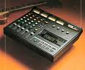

Tracks 1&2 – Drums and Bass.
Tracks 3&4 – Guitars and Keyboards.
Bounce down onto a single or stereo track
Tracks 1&2 – Backing Mix
Tracks 3&4 – Vocals and solo instruments.

For the first time, unsigned bands were able to produce recorded material, employing the techniques that signed bands enjoyed in professional recording studios without the necessity of hiring ‘demo’ studio time in four and eight track recording studios

Another significant development in the home demo’ at this time, was the move from the rehearsal/recording space into the bedroom. In the early eighties, the introspective singer/songwriter fully emerged, clutching demo-tapes of their multi-tracked acoustic guitar based angst music. The porta-studio was small and could easily fit on the desk on a bedroom. Artists developed their virtuoso skills, using drum machines and playing all the other parts – bass, keyboards, guitars themselves. It was these artists who defined the palette for music production that dominates to this day. Technology – particularly digital technology has merely refined this template. Multi-timbral MIDI synthesisers, computers and soundcards allowed for a much greater flexibility and many more tracks available to record onto until, with the emergence of high quality mixing consoles of any size and configuration, it became possible to produce recordings of an industry standard, suitable for release and distribution.

- Hybrid Systems & Sampling (1988-2000)

–TECHNO! TECHNO! TECHNO! TECHNO! –

Before the advent of digital production in the consumer/prosumer market, artists would work with hybrid analogue and digital systems. A home studio setup would typically consist of a micro computer – usually an Atari 1040 ST with built in MIDI ports – an open reel multi-track or portastudio, a MIDI sync unit such as the MOTU Midiman, a multi-timbral synthesiser such as the Korg M1 or, most radically, an AKAI S950 multi-timbral sampler and a DAT or Minidisc for stereo mastering.

It was an interesting time to be a home recording artist and in many ways it marked the end of guitar-based music for a decade. The singer/songwriter evolved into the DJ/Mixer. Multi-timbral digital emulators and samplers each gave you 8-16 individual tracks of instrumentation, recorded on a MIDI timeline using software such as Cubase v.3. In analogue days, this would have required a professional 24 track studio and musicians to play the instruments. Now, it cost only the one tape recorder track to stripe the MIDI timecode, leaving an extra 3/7 tape tracks free for acoustic based instruments such as guitars and vocals.

The introduction of the AKAI S950 12 bit sampler revolutionised music and was the first time that artists were actually able to initially bypass record labels to achieve success. Ironically, it was the reverse of the first era of home recording, where artists attempted to capture their live sound. Dance producers with no formal music training or musical virtuosity whatsoever could sample loops of old recordings, usually STAX funk records, and combine them to create new music. They would make ‘white label’ 12” discs and play them in the clubs. If the track created a ‘buzz or vibe’ a record distributor such as Virgin or EMI would then release it. In the early 1990s, Top of the Pops was a pretty dire place as acts would emerge and disappear on a weekly basis and would typically consist of a black R&B singer performing the sampled vocal whilst two non-descript techno-nerds stood behind keyboards and clapped in time. I suppose the best example of this would be ‘Ride on Time’ (1989) by Black Box that contained no original music whatsoever. Even the vocal, which was mimed by an attractive black model whose breasts bounced most engagingly, was actually a sample of R&B singer Lolleatta Holloway from a track called ‘Love Sensation’. Holloway had achieved some commercial success as one of The Weathergirls two years earlier with ‘It’s Raining Men’.

However, some things didn’t change, particularly the home studio artists use of cheap, discarded and seemingly obsolete technology – in particular, old VCO synths and drum machines, which were either retro-fitted with MIDI, or sampled. The entire ACID rave dance culture of the late 1980’s and House music of that period as well had at its core the now iconic TRS 808 drum machine and other predominantly acousmatic tone sources. Terminology also developed at this point. Instead of ‘recording a song’, artists would now look to ‘build a track… innit?’

- The State of the Art

And finally---

Demo-recordings fulfil a different purpose today. They are no longer produced solely for the benefit of A&R departments or management companies. The band member(s) responsible for songwriting will record demos to play to the band. Indeed, such has been the blurring of the boundaries between a home demo and commercial productions that long established mainstream bands will now release early demos of their greatest hits repertoire. In decades past, the equivalent would have been an album of ‘B Sides and Rarities’. In the mid 1990s, The Beatles (yes, them again) released a series of three double CD collections of unreleased tracks, out-takes and alternative versions of well-known tracks and live performances that were previously only available as ‘bootlegs’. The Beatles ‘Anthology’ proved highly successful and was accompanied by the Apple produced Beatles Anthology television series (Nov 1995) and the Anthology book (2000).

Interestingly, the surviving band members at that time, nicknamed ‘The Threetles’ decided to produce two new tracks to promote these releases, constructed from two John Lennon songwriting demo tapes, originally recorded in the mid to late 1970s. ‘Free as a Bird’ (written by Lennon in 1976 after his long drawn out but ultimately successful fight for a Green Card) and ‘Real Love’, recorded in 1979 or 1980 on a Portastudio, with instrumentation consisting of piano, vocals and a simple drum machine. Both of these songs were incomplete – fragments of ideas. Every songwriter, especially those who record in home studios will recognise this process, where you only actually complete a song once you have begun the process of recording it properly, as opposed to the ‘songwriting’ demo, where writers will record a work in progress in order to remember it months or even years later when they are looking to develop new material. Lennon’s demos were exactly that and the remaining Beatles were able to complete the songs. Whilst ‘Real Love’ was essentially complete in structure, ‘Free as a Bird’ needed to be finished off and so they wrote a middle eight, which they repeated twice – once with a McCartney vocal and once, as a bridge by Harrison into his slide guitar solo.

Only a few years earlier, this would have been an impossible task, but with the rise of digital recording, they were able to capture the original demo, clean it up through digital manipulation and noise reduction algorithms, split it into sections and overdub vocal harmonies, instrumentation and the new middle eight.

Staying with The Beatles, the 2006 release ‘Love’, produced by George Martin and his son Giles for the Cirque du Soleil theatrical production of the same name, was essentially a re-mix mashup – (a blend of two or more different songs – the vocal of one usually placed over the top of a different track). This has its origins in the Musique Concrete techniques developed by Pierre Schaeffer and refined by the BBC Radiophonic workshop by innovators such as Delia Derbyshire and the founder Daphne Oram (who actually was more interested in the electronica of Stockhausen -Google ‘oramics’). The first significant mashup release was in 1990 with Susanne Vega’s acapella song ‘Toms Diner’ sampled and remixed by dance act DNA. This technique has become enormously popular and quite a bit of mashing happens in the TV show ‘Glee’ (apparently).

This brings us up to modern times. It is possible to now record a commercial quality release with almost no bespoke equipment other than a MIDI ‘Mother’ keyboard, a cheap mixer costing less than £80, an SM58 dynamic microphone £60 and software that comes bundled free with a Mac (Garageband) or if you are really professional, Apple Logic Pro 7 (£400) (unless you are a student, when it costs £125). All synthesisers, emulators, guitar amp modelling and samplers are included as part of the D.A.W. software. It is now possible to record a track, mix it internally, render it directly as an MP3 or Aiff 44.1 khz file and post it in iTunes or social networking sites. In 1970, John Lennon wrote ‘Instant Karma’ on day 1, recorded it on Day 2 and released it on Day 3 – what a long and tedious timeframe!

Something else to consider – what have we lost as artists when we are no longer required to creatively rise above technical limitation? It must be so intimidating. There are no excuses – no excuses at all!

Technology Timeline

(i) The reel to reel tape recorder (1950s)
(ii) The Phillips cassette recorder (1960s).
(iii) The Revox A77 reel to reel tape recorder (60s & 1970s).
(iv) The Teac simul-sync four track reel to reel tape recorder (1973).
(v) The Tascam Porta 144 four track cassette recorder & mixer (1979).
(vi) The Fostex r8 eight track reel to reel tape recorder.
(vii) The Tascam model 5 mixer (1975)
(viii) The Studiomaster 16/4/2 (1978)
(ix) The Soundcraft Delta with phantom power (1989)
(x) The compact mixer with sealed Alps faders & phantom power for less than £100 (1998)
(xi) Hybrid Systems (1987 – 2000)
Midiman Syncman
Atari 1024 xt Micro computer with built in MIDI
Cubase v.3 audio/midi sequencer
Multi-timbral synthesisers
Fostex r8 reel to reel tape recorder
CD recorders (mastering)
(xii) Building Beats - The rise of the producer/DJ and Dance Culture (1987 - )
Akai S950 sampler
DAT
Digital multi-tracks
(xiii) Virtual studios – personal computers, soundcards & soft synths (1997)
Virtual distribution – the internet & iTunes as a business model for a new music industry. (2000)

